

**Software Factory Architect (m/f)**

**“NTX is a fun, interactive workspace which focuses on innovative culture, inclusion and sustainability”**

About You

**NTX is a young start-up founded by powerful and leading IT companies**

* CLEAR VISION FOR SOFTWARE CHARACTERISTICS AND FUNCTIONS   
  with a proven experience in a similar position
* PROVIDE TECHICAL GUIDANCE AND COACHING TO DEVELOPMENT TEAM.   
  Be able to write and promote best practices.
* DRIVEN BY THE DESIRE TO AUTOMATE AND SCALE EVERYTHING   
  Be able to understand domain specific topics and how they impact the team’s operational success.
* EXCEPTIONAL COMMUNICATION SKILLS   
  coupled with strong customer satisfaction acumen.



Our mission is to manage and evolve the Network, Security and UC/VC infrastrustures of the European Commission. We provide a challenging and leading edge technological environment with unpreceded performances and capacities, supported by the open source community and the biggest technology vendors.

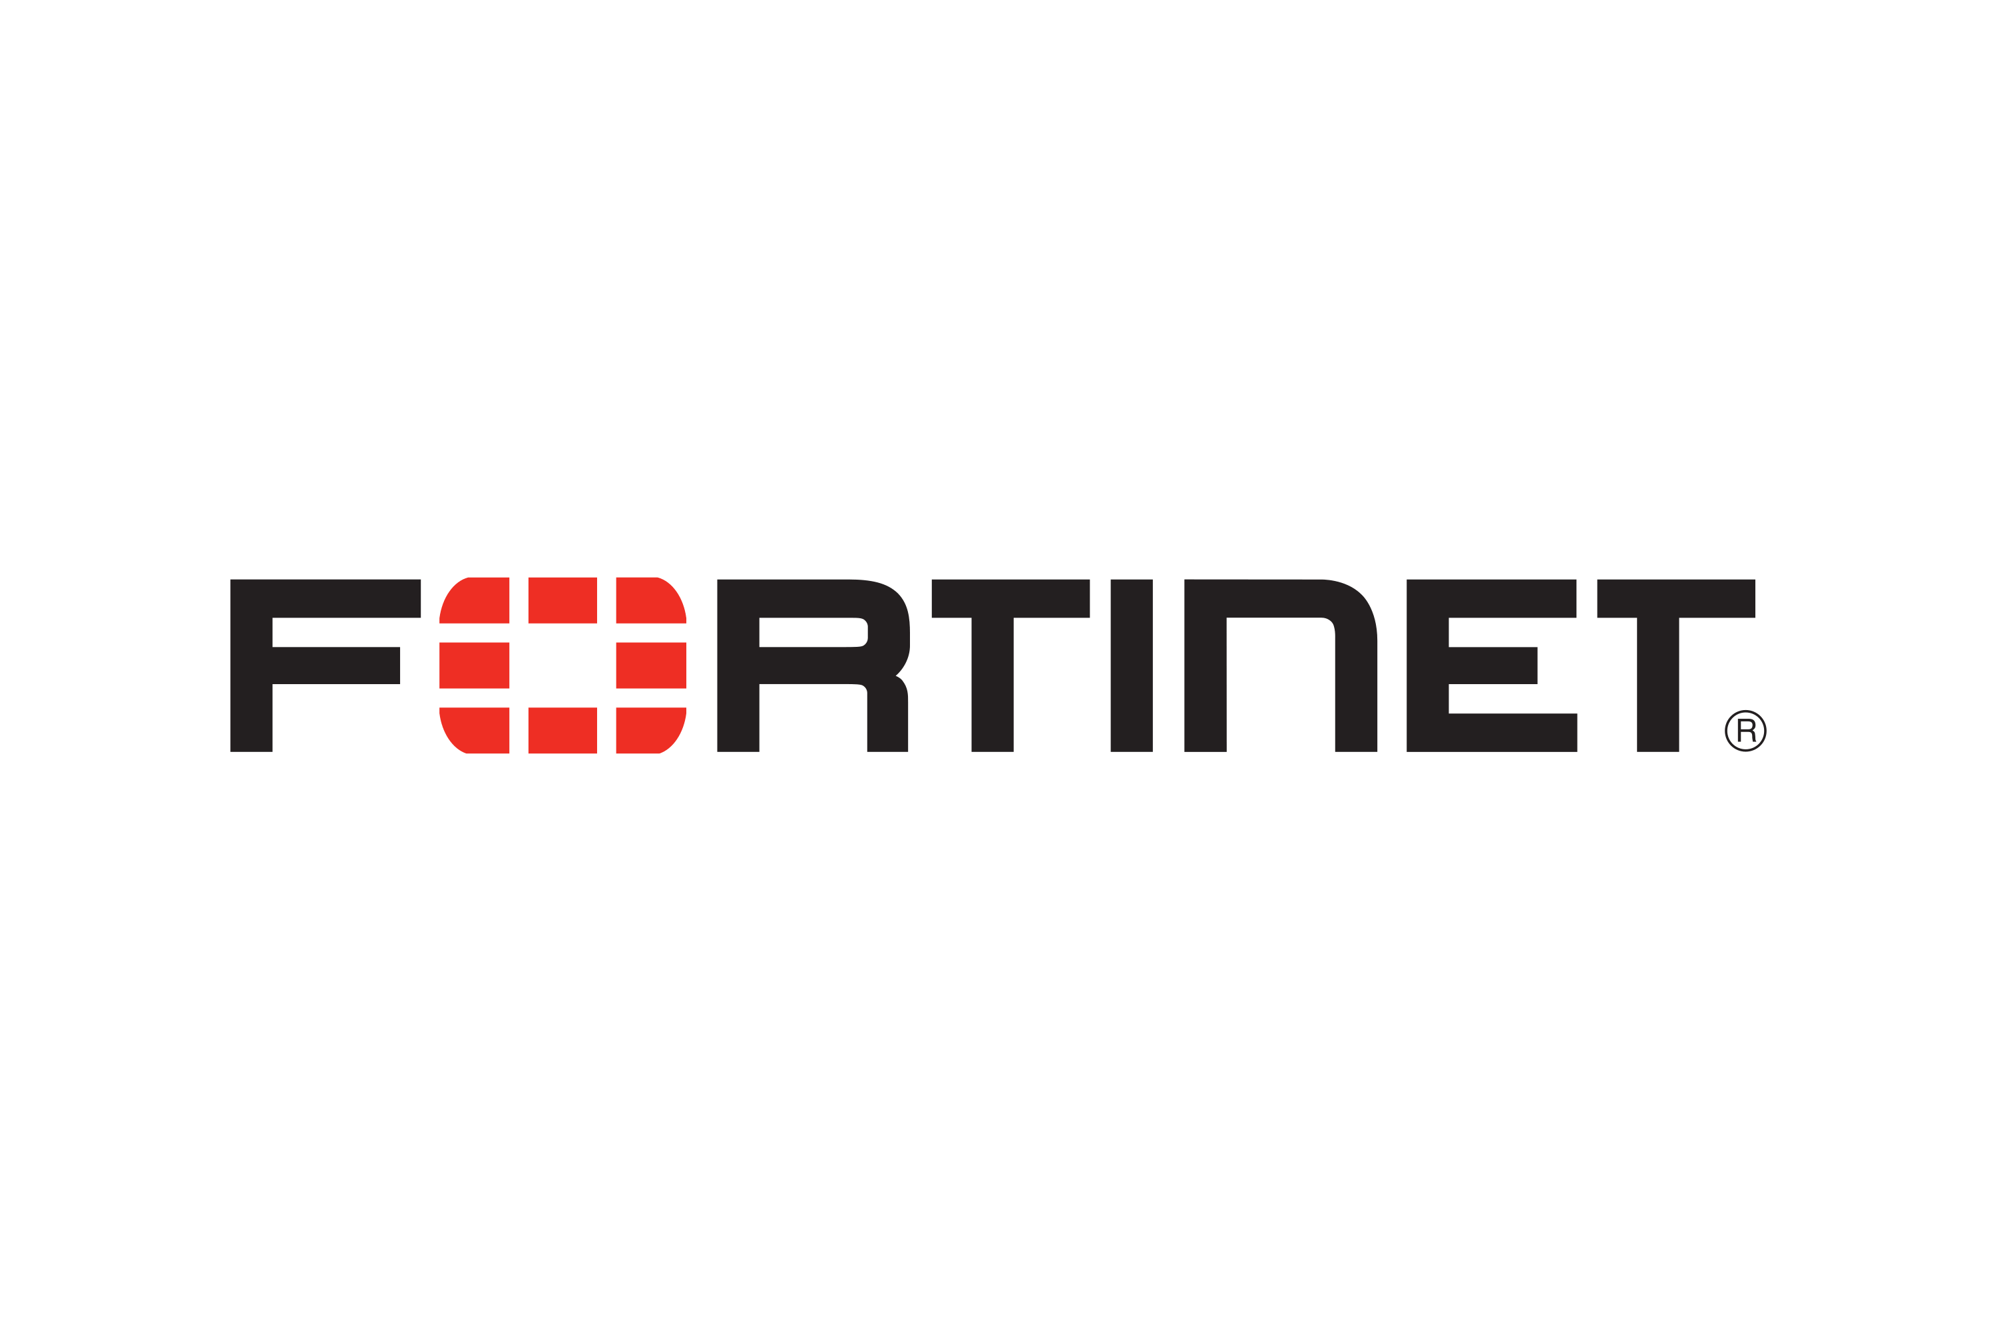



Afficher l’image source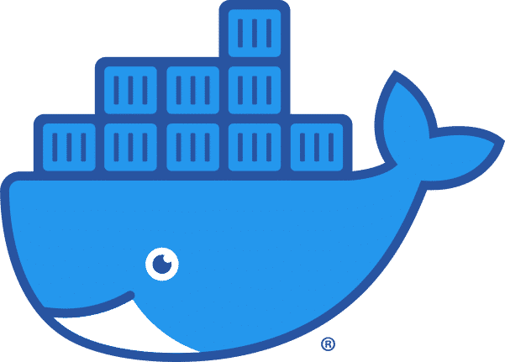

**As a Software Factory Architect @NTX, you will …**

* Participate to projects, initiatives and designs
  + Should be able to study the space to gain understanding of the needs
  + Maintain proactive async communication with staheholders to provides updates
* Establish strong partnerships
  + To collaborate well with EC service managers, internally and with partners
  + Build strong relationships with differents teams.
* Build
  + Design concrete solution which meet well defined-objectives
  + Establish comprehensive documentation, guidelines and blueprints.
  + Offer bespoke support where high priority opportunities arise.
* Be Team multiplier
  + Improve collaboration and remove friction within and around our team.
  + Write high level technical documentation
  + Promote a positive, productive and constructive engineering culture toward adopting best practives, experimentations and aiming quickly toward success.
* 8+ years experience working in a Software architecture position
* Possess strong technical background with emphasis on Python, Perl, containerization and CI/CD.
* Motivation to create and improve existing application
* Experience using version control, CI/CD.
* Ability to follow devops approach.
* Enjoy collaborating and sharing ideas with team
* Be comfortable working remotely and potentially asynchronously by learning on your ability to communicate written ideas effectively with strong attention to details
* Motivated to deliver high quality solutions quickly

**As Network Engineer @NTX, you will**

**You may be fit for this role if you have…**

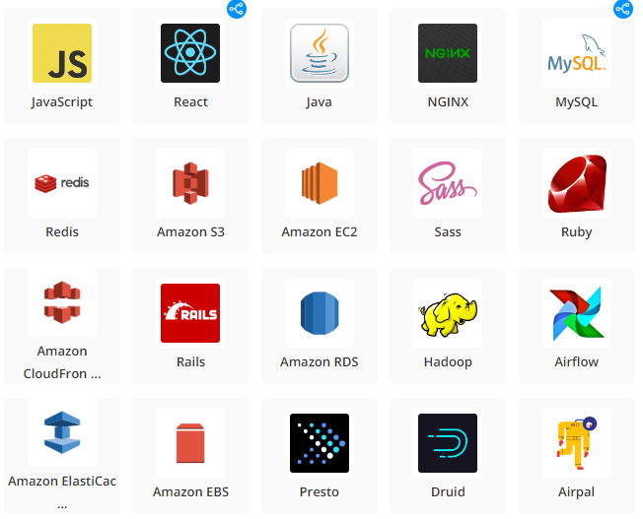<https://logos-marques.com/wp-content/uploads/2021/03/Linkedin-logo.png>

* Competitive rewards package which includes
  + Bonus for performance and annual salary review,
  + Car,
  + Pension plan
* Learning programs which include paid certifications and courses
* Flexible working hours and the choice to work remotely
* Team lunch, NTX event (bowling…)

**You will get…**